Initial Referral form for the Befriending Service
Thank you for considering our befriending service. Our lovely volunteers act as a good neighbour who pop in for a chat or will phone once a week. Unfortunately, we not a shopping or respite service and cannot be a replacement for paid services, our volunteers are not trained to deal with complex issues.
- Is this a self-referral?
☐Yes (Continue to question 3)
☐No (Continue to question 2)
- Is the person aware they are being referred?
☐Yes (Continue to question 3)
☐No (The person you are referring must know about it before we can accept the referral.)
- Are you / is the person you are referring aged over 65?
☐Yes (Continue to question 4)
☐No (Sorry our funding only enables us to help people over 65 you could try contacting Derbyshire Trusted Befriending Network)
- Do you/ does the person you are referring live in the High Peak area? * (See map below)
☐Yes (Continue to question 5)
☐No (Sorry our funding only enables us to help people who live in Buxton or the High Peak)
- Do you / does the person you are referring feel lonely or isolated? Priority will be given to those without regular sources of companionship.
☐Yes (Continue to question 6)
☐No (Sorry our funding only enables us to help people over 65 who feel lonely or isolated you could try contacting Derbyshire Trusted Befriending Network)
- Do you / does the person you are referring have any of the following – mental health issues, dementia, learning/physical disability, long term illness/medical condition, behaviour problems, communication problems?
☐Yes (Please see the notes below before continuing)
☐No (Continue to the boxes below)
All referrals will be assessed on an individual basis; however, the following are unlikely to meet our criteria for eligibility –
- People with personality or behavioural problems, serious mental health, especially those who are in crisis or who we are unable to carry out a suitable risk assessment.
- People with memory or mental health issues if Connex is to be their only means of support.
- People with moderate to severe dementia. For example, they are unable to remember appointment times or build a relationship with our volunteers.
- People who are living in conditions that are deemed dangerous or a risk to health by our risk assessment.

The red line on this is map is a guide to where our Befriending Service covers. If you are unsure because you seem to be right on the boundary please contact us for clarification.

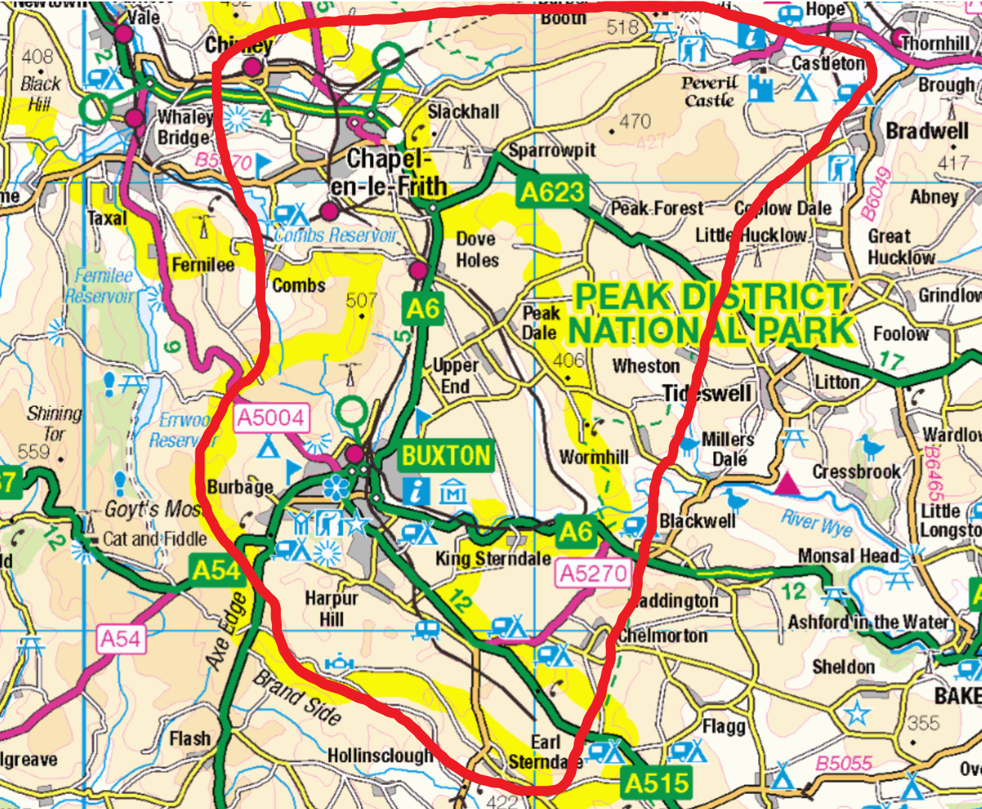

ABOUT YOU OR THE PERSON YOU ARE REFERRING
Date of Referral:
Name : Click or tap here to enter text. D.O.B: Click or tap here to enter text.
Address: Click or tap here to enter text.
Telephone Number: Click or tap here to enter text.
Email address: Click or tap here to enter text.
Date of referral: ____________________________________________________________________

ABOUT THE REFERRER

Referrers Name: Click or tap here to enter text.
Job role/relationship to client: Click or tap here to enter text.
Your Contact Number:Click or tap here to enter text.
Email address: Click or tap here to enter text.

GP DETAILS

Name of Doctor: Click or tap here to enter text.
Address of Practice: Click or tap here to enter text.
Telephone Number:Click or tap here to enter text.

IMPORTANT CONTACTS
Contact names and telephone numbers in case of concern – relative, neighbour, social worker…

WHY A BEFRIENDER?
Why would you / why do you think your client would like a befriender?

Have you / your client recently been bereaved?

WHAT TYPE OF BEFRIENDING?
Please tick which of the following you / your client would be interested in (you can tick more than one).
☐One to One Befriending. A volunteer will visit you in your home for about an hour a week.
☐Telephone Befriending. A volunteer will call you for about an hour a week.
☐Group Activities. Join in with a group. We have a range of activities, Kurling, Art, Walks, Coffee Mornings… If you are interested in these or want to find out more by ticking the box you give us permission to pass your contact details onto our Group Activities Coordinator who will then be in touch with you.

OTHER INFORMATION
Is there anything else we need to know or any other information you would like to add such as – regular callers/visitors, carers, medical needs, other services involved, pets in the home…

INITIAL CONTACT (Leave blank if it is you or the client named above)
Who is the best person for us to initially contact about the referral? We ask this as sometimes it is not the person who has been referred.
Name: Click or tap here to enter text.
Relationship to Client: Click or tap here to enter text.
Contact Number: Click or tap here to enter text.

We do have a waiting list and it can take a little while to match people with a suitable volunteer as we have to source the volunteer and train them, please be patient with us.
If you would like to make any changes to this form please contact us. If you would like to discuss our procedure or obtain a copy of any of our policies please contact us (see above)
Please return the completed form to Emma (details above).
INFORMATION IS KEPT IN STRICT CONFIDENCE

